Visualizing Keywords Over Time

Akanksha Shaktia  [ass546@nyu.edu](mailto:akanksha.shaktia@nyu.edu)

Zhongheng Li [zl1761@nyu.edu](mailto:zl1761@nyu.edu)

Priyanshi Shah [ps3296@nyu.edu](mailto:ps3296@nyu.edu)

Riya Patni [rsp378@nyu.edu](mailto:rsp378@nyu.edu)

Github Page : <https://github.com/heng2j/Visualizing-Keywords-Over-Time-with-D3>

Working Demo : <https://heng2j.github.io/Visualizing-Keywords-Over-Time-with-D3/>

Video :

**What is the problem you want to solve and who has this problem?**

The problem at hand is to develop a generic technique to visualize the change in keywords extracted from any given dataset over a period of time. The given dataset is Yelp’s (reviews) dataset and the aim is to find the frequently occurring keywords, their changing trends over time, along with their appearance and disappearance over a period of time; augmenting better business decision based on the frequency. Analysis of these trends would help the business owners understand what people talk about their businesses and how these topics change over time.

To gain better insights, our team decided to focus on a specific class of business, which is restaurants, in a particular state of the United States, which is Pennsylvania. The idea is to realize that if the trends can be seen for a particular business category, then it can be scaled to accommodate other categories too, since the system has been strategically kept generic.

By visualizing such keywords, restaurant owners can gain insights into the factors that were most talked about in a particular month about restaurants in general by the people of Pennsylvania.

The resulting visualization essentially is aimed at serving other business models that would require making use of these trends.

**What are the driving analytical questions you want to be able to answer with your visualization?**

**Questions:**

1. What are the top 15 keywords (scalable upto 25) for each month extracted from the dataset over the year?
2. Which of these monthly keywords made it to the top keywords of the entire year – thereby implying they were most frequent throughout the year?
3. How does the ranking of the keywords change over time?
4. Which keywords appear or disappear over a period of time?
5. What are the top 5 reviews/comments that contain a particular word?

**Description:**

1. **What are the top 15 keywords (scalable upto 35) for each month extracted from the dataset over the years?**

Given a dataset, which are the top 15-25 keywords that constitute the trending words or most frequently used words for restaurants reviews in Pennsylvania. By listing such words and sorting them by a factor, say, frequency, we can understand the driving factors for a business and what are the most commonly associated words with it. For example, keywords like ‘BBQ, ‘service’, ‘pizza’ and frequency of each of them.

1. **Which of these monthly keywords made it to the top keywords of the entire year – thereby implying they were most frequent throughout the year?**

Now that we can see all the frequent words for each month, question is, are these significantly important from the entire year’s point of view? If yes, they would appear in the year’s column that shows the top words for the entire year. If a word has made it to that list, we know its trend has been more or less frequent over the entire year.

1. **How does the ranking of the keywords change over time?**

After finding all the top keywords, it is important to understand the life cycle of individual keyword over a period of time. That is, we need to visualize the ranking of this word at different points in time. So if a word appears as important in the month of January 2014, we look at its ranking over all the months of 2014 to see if this keyword has recently gained importance or has been important for many months now.

1. **Which keywords appear or disappear over a period of time?**

This is a crucial question for the problem. Every month, a set of top 15-25 keywords are found. For example “thanksgiving” appears in the month of November as a frequent word, while “Valentines” appears as a frequent word in February. Since these words don’t appear in any other months, we identify them as outliers. Certain words keep appearing and disappearing every month. Visualizing the set of newly appeared/disappeared keywords will thus give us an idea about which keywords started/stopped gaining importance over a period of time.

1. **What are the top 5 reviews that contain a particular word?**

For a particular frequently occurring keyword, what are the top 5 reviews that contain the word most number of times? This will find interesting and important reviews and the user might want to dig in the details of that review.

**What does your data look like? Where does it come from? What real-world phenomena does it capture?**

The main dataset, [Yelp Dataset Challenge](https://www.yelp.com/dataset_challenge), contains details and reviews of businesses over a period of 20 years across different locations in the United States. For the sake of simplicity, we have processed this data so that it shows the reviews and details for all the restaurants in Pennsylvania for the year 2014 and 2015. This processing was achieved using the unique business IDs, categories and addresses mentioned for each business. Following are the attributes and their descriptions used for the visualization.

|  |  |  |  |  |
| --- | --- | --- | --- | --- |
| Attribute Name | Attribute Type | Meaning | Values | Derived? (if yes explain how) |
| Business Id | Categorical | Unique ID assigned to each business unit. | Alphanumeric characters | No |
| Business category | Categorical | Identify which category this business ID belongs to, whether it is a restaurant or a garage and so on. | Text | No |
| Text | Unstructured text | The user comments posted on Yelp for each business. | Text | No |
| Keywords | Text | The frequent keywords derived from the text (comments) using Natural Language Processing | String | Yes. Keywords are generated from the existing dataset and stored in a new JSON file. |
| Frequency | Quantitative | For each derived keyword, this shows the number of occurrences of it in the entire dataset. | Number | Yes. By counting the number of occurrences of the derived keyword, we store the frequency of keywords in each month, which can be sorted and aggregated for better visualizations. |
| Mentioned | Unstructured Text | For each keyword, list the top reviews that contain the most occurrences of this keyword | Text | No. Just filtered out based on the top keywords. |

**What have others done to solve this or related problems?**

For the visualization to impart correct and meaningful information, extracting the right keyword from the whole content is crucial. As a part of our initial research, we looked for appropriate algorithms to find such important words from the text. For this purpose, we referred to the following page published on ResearchGate which is a hub of such independent researches. This paper describes the efficiency of a keyword extraction technique known as RAKE (Rapid Automatic Keyword Extraction.)

Link to the paper: <https://www.researchgate.net/publication/227988510_Automatic_Keyword_Extraction_from_Individual_Documents>

Another beautiful visualization project that we came across is the Google Books N-gram Viewer. This is a simple and elegant visualization technique to show the occurrence of keywords over a time span. The ticks on x-axis depict a span of twenty years however, as you hover over the line, it shows information of the intermediate years. The user can also search for a keyword of his own choice to see its frequency. We plan to include a similar chart in our project to show the use of keywords over time.

Link to the project:

<https://books.google.com/ngrams>

Real-time project:

As the importance of data analytics is growing, companies are finding more and more applications for Data Mining. Often while browsing through web pages, we see dynamic advertisements on the margins or bottom of the page. However annoying they may seem, but if we notice them carefully, they are related to our previous web searches. This is a real- time application of frequent keyword extraction from the user’s browsing history to extract what the user might be interested in and providing exactly those advertisements to him.

The project that we have shared here is a similar project created for a startup based in San Francisco to match advertisers to content providers in a context-specific way. In the post, the developer has shared an algorithm that helped in picking the right keywords from the entire dataset comprising of user’s browsing history.

Link to the paper:

<https://people.csail.mit.edu/lavanya/keywordfinder>

How it is related: The project describes a step by step approach on how to extract keywords and rank them based on different attributes or features such as how frequent they are, or how recently they were used. This is similar to what we are planning to incorporate in our project.

**Design Iterations**

Initial Mockup:

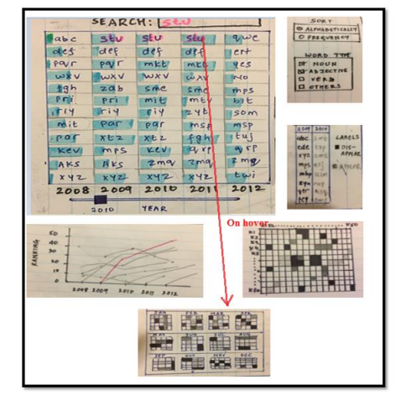

**How to read the visualization:**

The main chart shows the the top 50 keywords for the year 2010, which automatically shows the words for two of its preceding and succeeding years, i.e., 2008, 2009, 2011, 2012. This is shown in the form of a list view. The blue bars in the background of each word indicates its frequency. Thus, we can compare that, for the year 2010, “wxv” has the least frequency and “kev” has the highest frequency.

This is the default visualization. User can choose a year of his choice by using the slider at the bottom of the list view. For the chosen year, we see the line chart and a word-matrix getting updated. The line chart shows the life-cycle of the words extracted for that year, over a period of 5 years. Note that, all these lines are initially greyed out. When the user chooses a word from the list or types a word in the search box, the line graph for that keyword is highlighted, and at the same time, its Calendar View is generated, as shown below. This calendar view shows the frequency ranking of this word throughout the year 14 2010, for each month of the year and each day in the month. This helps us compare the trends for a particular season or special trends on the weekends etc.

The word – matrix focuses on co-occurrence of words for the year 2010 and shows us which two words occurred together most frequently. When we click on a grid for say keyword Ki and Kj, we see that the line chart highlights the graph for those keywords and we can compare their trends over a period of 5 years, as shown below. These words will also be highlighted in the list view.

**Project Intermediate Update**

At this stage, we decided to show the visualization month-wise, instead of year-wise, since yearly generated keywords did not give an interesting trend. We processed the dataset such that the keywords and their frequency are stored month-wise. To add more granularity, we implemented a daily-data based line chart that shows how a word has performed on each day of the month. We planned to show this daily data based line chart such that it helps to compare two or more words, by selecting the words from the column on the right.

Main chart: List View chart

The main chart shows the top keywords of all the months of the selected year in a list-view where each month is represented as a column. The list chart is sorted by frequency in descending order. User can use the slider and change the year to view top keywords of all the months of the corresponding selected year.

The blue bars in the background of each word is proportionate to the frequency of each word.

Upon hovering on each word, that particular word is highlighted in all the columns allowing user to easily understand the change in ranking of that word over a period of 12 months.

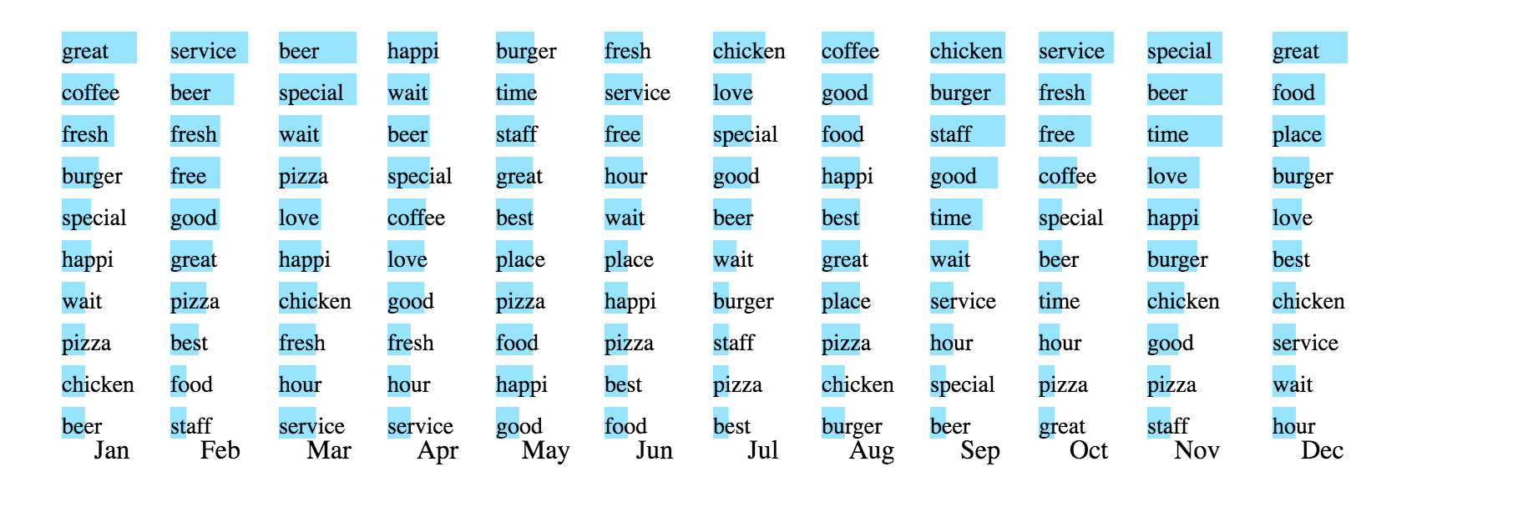

The line chart shown below allows user to choose words from the side panel, and visualize their daily performance. It can either be used to analyze a particular word’s performance, or comparison of multiple words. When a user selects a word, its line is highlighted, when a user selects another word, we see one more line with a new color getting highlighted. De-selecting these words will gray out existing lines.

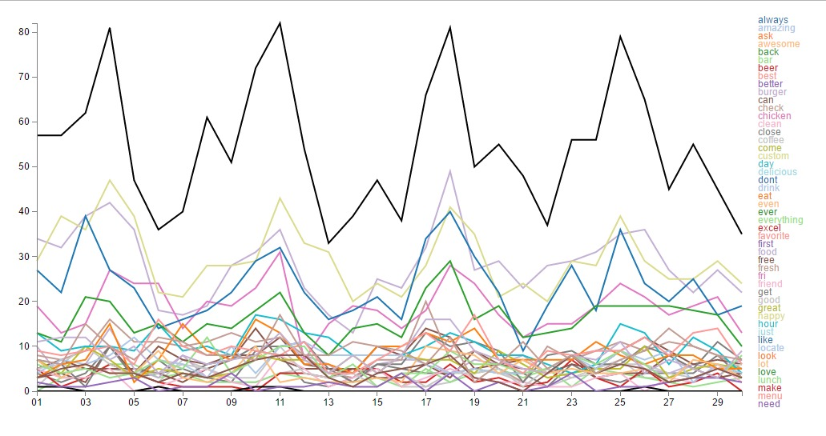

After discussions with the mentor, we came to a conclusion that using line chart to show daily performance is not a very efficient visualization technique. Instead, joining word occurrences in adjacent columns using lines to show the word flow in the list chart seemed like a visually appealing technique, and thus we dropped the idea of using the line chart.

Final Visualization

The final visualization was aimed at answering all the questions proposed in the proposal.

To answer the question about the top 15-35 words over a period of time, the list chart is designed as below that shows the words rank wise for each month, with their frequencies being visualized as horizontal bar charts in the background. By looking at each month’s list, we can see the top words for that period. The last column shows the top words for the entire year. These are the words that were appeared most frequently in the comments over the entire year.

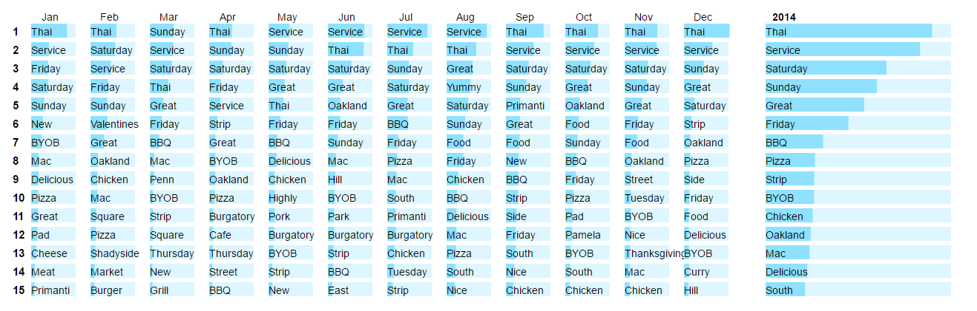

To answer the question about which words made it to the most frequent words of the year, we allow the user to hover on a word, upon which its occurrences get highlighted in all the columns wherever it appears, including the last column. So when a user hovers on a word ‘Thai’, it gets highlighted in all the columns and we can see that it seen in the 2014 column. However, hovering on the word ‘food’ shows that it does not appear in the year’s list, meaning it wasn’t that popular for the year.

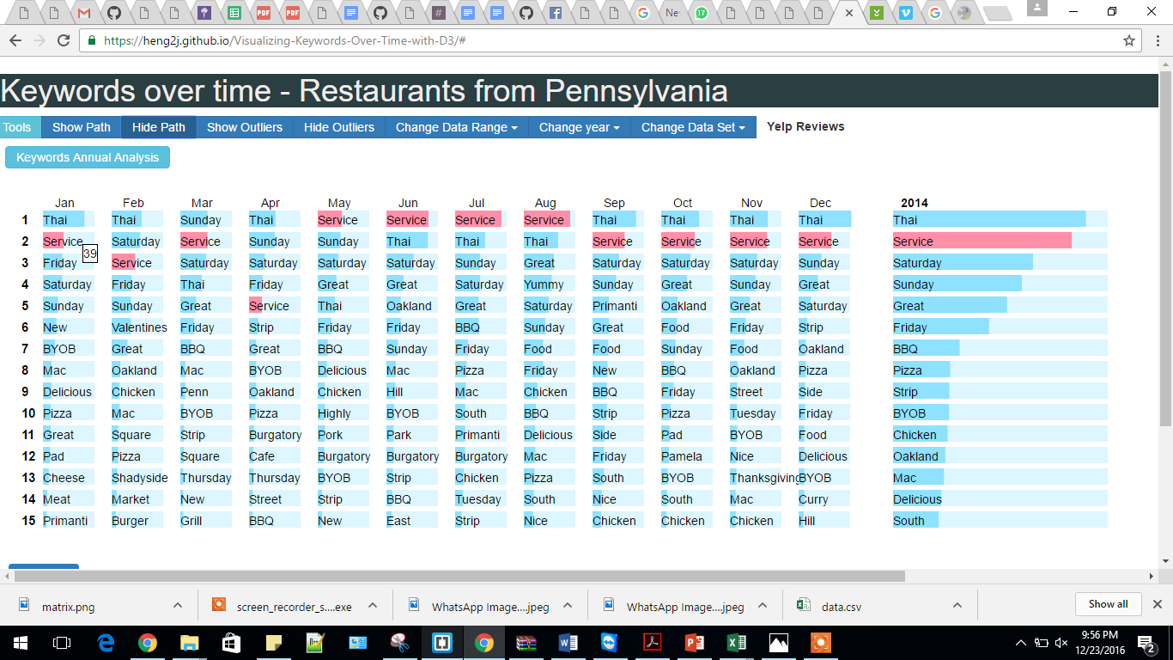

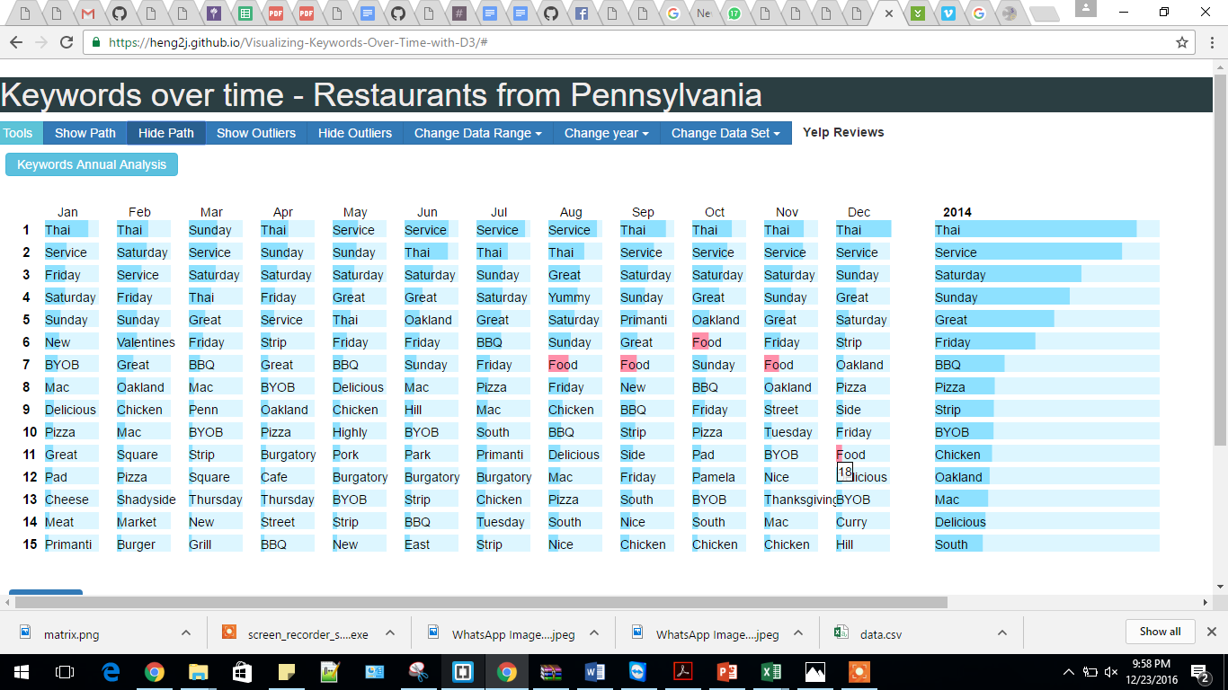

The next question is about how the rankings of the word change over time. To answer this, we use the lines combined with the bar highlights. When a user hovers on word, its occurrences in all the columns get highlighted, and interested user can follow the lines from one month to another to analyze its trend.

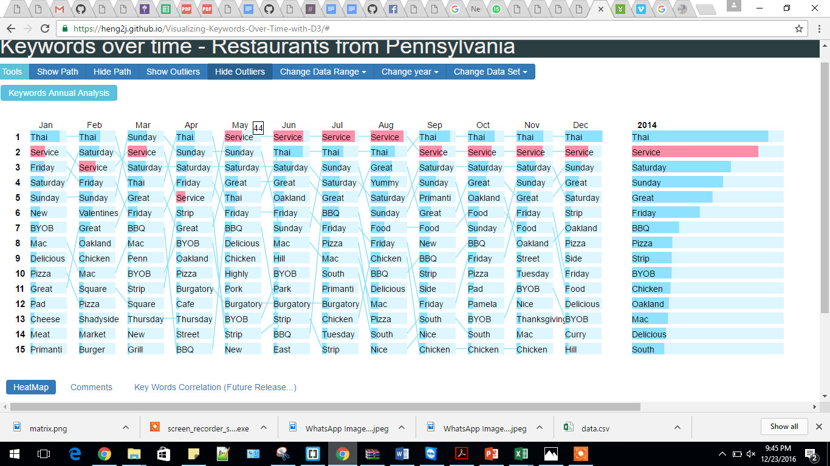

This implementation answers another question, which words disappear/re-appear over a period of time? When the user follows the line, it may so happen that a word has no outgoing line or no incoming line, this means that this word disappeared or re-appeared, respectively. For example, the words ‘Mac’ and ‘Sunday’ do not appear in the first column, hence they don’t have incoming lines in the middle column. This means these words newly appeared or re-appeared in this month. And continue to trend in the following month, since they now have outgoing lines.

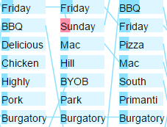

Upon clicking on a word, the bottom section of the dashboard populates the heatmap and comments for that word. The heat-map is a calendar-view representation of the word that shows how a word performed in that year, in each month, on each day. This chart is useful to find out whether a particular word performed better in a particular season – like fall or spring, or on special days like weekends or weekdays. It is interesting to find out trends using such a granular representation.

This calendar-view chart is populated for the clicked word which shows that this word was popular among the reviews during the months February-August, but its ranking reduced significantly in the subsequent months. This could be due to gaining importance of some other word over this.

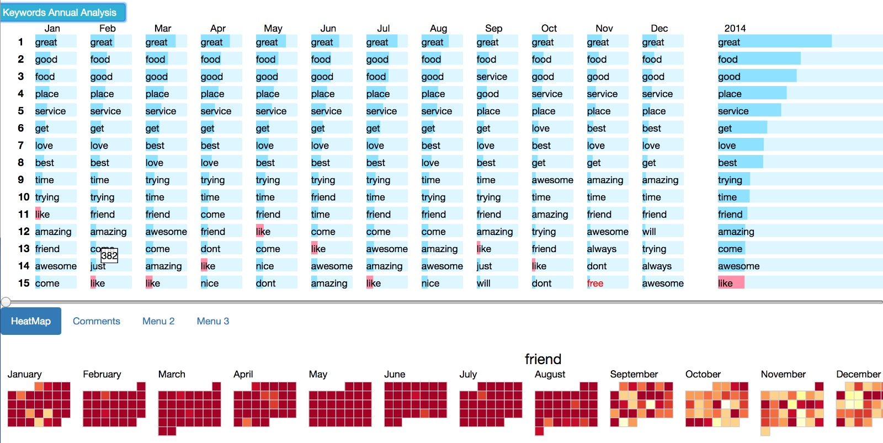

Another tab in the bottom section populates the top 5 comments that contain the most frequent occurrences of that keyword, which gives the user an idea of the different contexts in which the word was used.

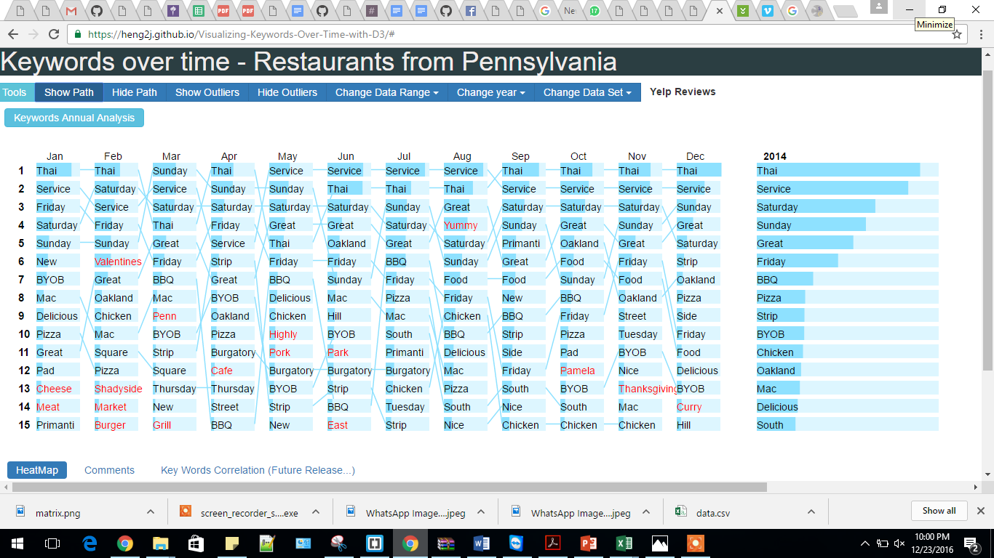

**Findings**

Based on the derived data, we drilled through the patterns and found out the word rankings by sorting the words in a month based on frequency. This helped us display the data in a sorted order, which is a visually effective technique, since the most important ones appear at the top.

In order to find out the outliers in this data, we analyzed the rankings to find out those words which trended only in one particular month throughout the year. This technique brought out three interesting observations.

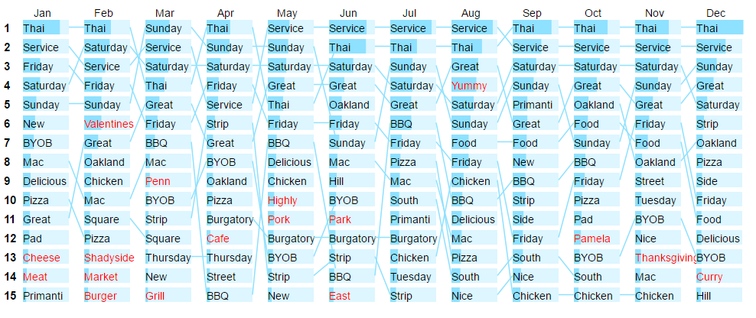

In the month of February, the word ‘Valentines’ trended as a popular keyword, since most comments mentioned eating at the restaurant on Valentine’s Eve. This shows that Valentines Eve is an important aspect to be considered for the month of February and restaurants can come up with special offers for Valentines. Similarly, in the month of November, the word thanksgiving trended.

The appearance of keyword Thai as the most popular implies that Thai is the most talked about cuisine among the people of Pennsylvania.

Another good observation is that, the trends are specific to the month, meaning, even if a word’s frequency has decreased or remains same in the subsequent month, it can still rise up in the ranking since it may be trending for that particular month compared to other words of that month. This can be seen from the following example.

The frequency of keyword ‘Friday’ in the month of March is 29, which is same in the month of April. However, it still rises up in the rank, since in the month of April, ‘Friday’ with the frequency of 29 is more popular than other words which have lower frequencies.

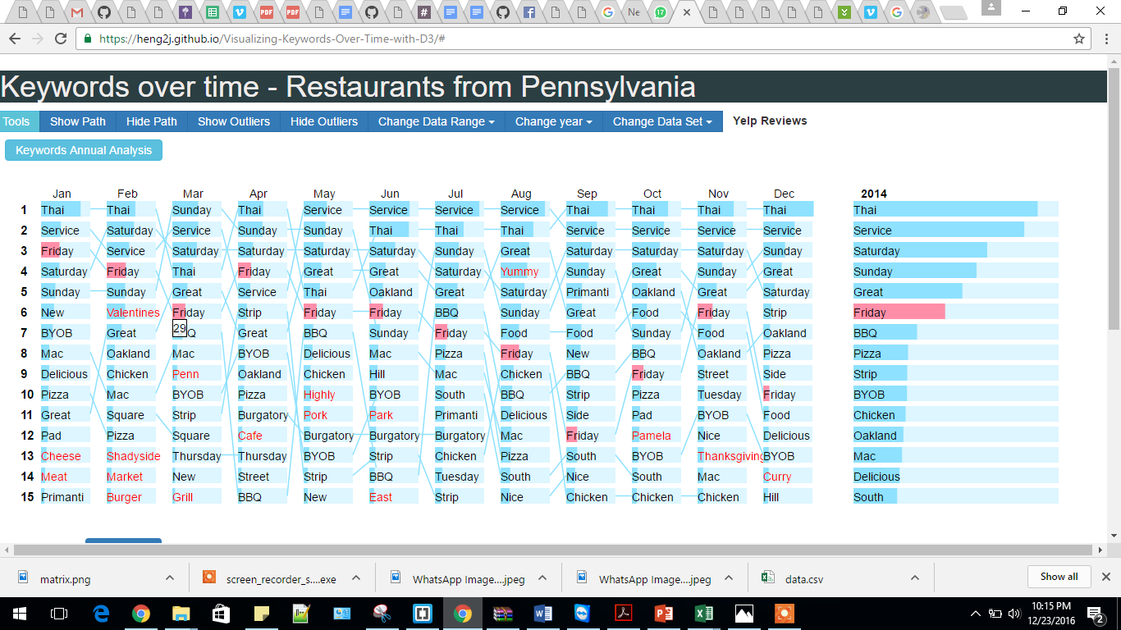

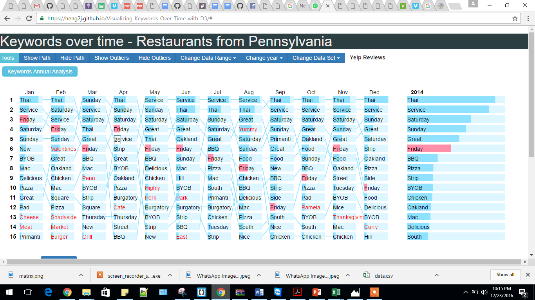

**Limitations and Future Works**

The major limitation of this application is failure to understand the sentimental impact of a keyword with respect to the business in consideration. Meaning, given a word in the list, was it used in a positive way or a negative way? Are users happy about it or complaining about it? To answer these questions, given a chance to further develop this project, we would apply sentiment analysis and tag each word with a positive/negative/neutral attribute, and color code them such that the user of the application understands that this word is popular because people love something about it, or hate something about it. This will give deeper insights into the business trends.

To add to the existing functionality, we can process the data further to visualize the words for each business unit. For example, by choosing a restaurant name from a drop down, we can visualize all the information shown above, for just that one restaurant. This way, owners can track the trending words and find out what are people talking about “their” restaurant, and not restaurants in general.

Further, we would also like to understand co-occurrence of two words using a matrix, which will give an idea of the frequently co-occurring words, that can tell us which topics are closely related. Such as ‘Cheese’ and ‘Pizza’. The idea of this visualization would be something like this.

